Given a binary tree, return the *vertical order* traversal of its nodes values.

For each node at position (X, Y), its left and right children respectively will be at positions (X-1, Y-1) and (X+1, Y-1).

Running a vertical line from X = -infinity to X = +infinity, whenever the vertical line touches some nodes, we report the values of the nodes in order from top to bottom (decreasing Y coordinates).

If two nodes have the same position, then the value of the node that is reported first is the value that is smaller.

Return an list of non-empty reports in order of X coordinate.  Every report will have a list of values of nodes.

**Example 1:**

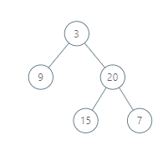

**Input:** [3,9,20,null,null,15,7]

**Output:** [[9],[3,15],[20],[7]]

**Explanation:**

Without loss of generality, we can assume the root node is at position (0, 0):

Then, the node with value 9 occurs at position (-1, -1);

The nodes with values 3 and 15 occur at positions (0, 0) and (0, -2);

The node with value 20 occurs at position (1, -1);

The node with value 7 occurs at position (2, -2).

**Example 2:**

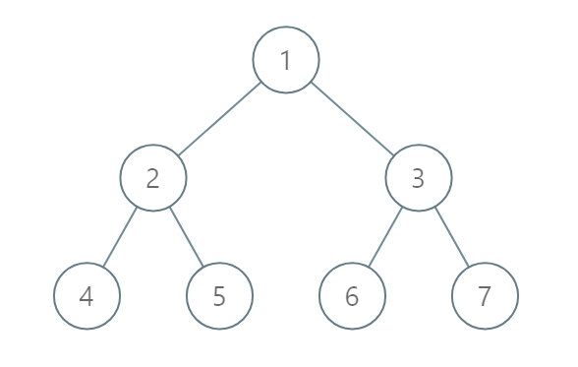

**Input:** [1,2,3,4,5,6,7]

**Output:** [[4],[2],[1,5,6],[3],[7]]

**Explanation:**

The node with value 5 and the node with value 6 have the same position according to the given scheme.

However, in the report "[1,5,6]", the node value of 5 comes first since 5 is smaller than 6.

**Note:**

1. The tree will have between 1 and 1000 nodes.
2. Each node's value will be between 0 and 1000.